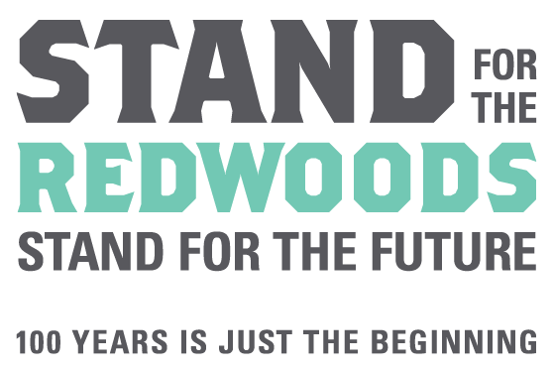

Education Grants Program
2017 Final Report Narrative for the Redwood Visit Category

All grant recipients: As part of your final report, we require a detailed narrative (in PDF format) describing the results and outcomes of your project. We do appreciate clarity and brevity: your narrative should be 2-3 pages long.
Please address each of the following topics in your narrative and attach it to the completed final report form. Be sure to a) present your narrative topically, using the numbered headings below, and b) fully develop the Project Summary, Target Audience, and Evaluation sections.
- Project Summary:
- Describe your classes’ field trip. What did you do to supplement the field trip? (pre-lessons, post-lessons, species reports, reflection writing)
- What were your goals for the field trip and how did you meet those goals?
- Target Audience:
- Who benefited from the field trip? How many people ultimately participated in the project?
- Tasks/Activities and Time Line:
- Outline the final timeline associated with the field trip; include major activities, achievements, and crossroads.
- Evaluation:
- How did you evaluate the success of your field trip? Did you accomplish your project goals?
- Explain how you shared information and results with the school and community.
- Describe any unanticipated program(s) or project(s) your League grant inspired, as applicable.
- How will your program/project continue past this funding year?
- Project Products: Please attach copies of all program products developed as part of your grant award, including:
- Photographs – please ONLY send electronically, by CD, email or dropbox
- Participant artwork, writings, songs, science project summaries and observations
- Curricula, activity sheets, publications, and/or resource lists
- Evaluation forms and/or student feedback
- Press releases

