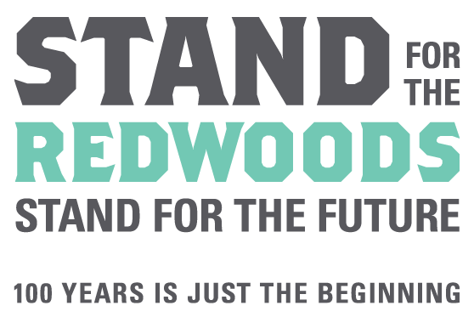

Education Grants Program Application Form 2018-2019

Section 1 – Project Summary
Organization Name:
Project Director:  (Primary contact for all grant related material) |  |  |  | Title:
Address:
Phone: |  |  |  | e-mail:
Project Title:
Project Summary / Abstract: In 200 words or less, briefly summarize and capture the essence of your project for the reviewers)

Amount Requested: $ |  |  | Total Project Budget: $
Number of youth your project will reach directly?
Percentage of participants part of the free and reduced price school lunch program? (if applicable)

What age group will you be working with?
When will the project take place? |  | From: |  |  | To:
Location of Field Trip(s)
Education Grant Category
- Redwood Visit (1-day field trip in a Redwood forest) $1,500 Grant Award
- Forest Immersion (3-5 field experience in a Redwood forest or bringing multiple schools on 1 day forest visits) $5,000 Grant Award
- Applying for 1 year of funding
- Applying for 3 years of funding

Section 2 – Narrative (required of all applicants)
Please complete the Application Narrative for the specific grant category you are applying for (ie. Redwood Visit or Forest Immersion). Attach the narrative to this application form as one PDF. All of the questions must be addressed for your proposal to be considered. The reviewers request that you present your narrative topically, using the numbered headings outlined in the narrative. We do appreciate brevity & clarity!

