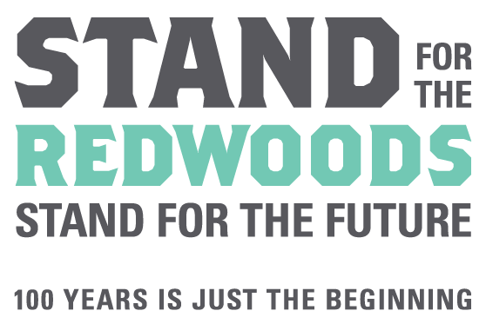

Redwood Education Grants Program
Final Report Form & Requirements
For Grants Awarded in 2018

Section 1 – Project Summary
Organization Name:
Project Director:  (Primary contact for all grant related material) |  |  | Title:
Project Title:
Project Quote (for publicity purposes): Please insert one quotation here that captures the success or uniqueness of your project (remember to list the name of the person who said the quote and their relationship to your organization). Attach any additional quotations for our use in promoting your project.

Final # of Participants Served: |  | Final Total Cost of Project: $
Final Project Timeline: | From: |  |  | To:

Section 2 – Narrative (required of all grantees)
Please complete the Final Report Narrative for the specific grant category your grant is for (ie. Redwood Visit or Forest Immersion). Attach the narrative to this final report form as one PDF. All of the questions must be addressed for your proposal to be considered. We request that you present your narrative topically, using the numbered headings outlined in the narrative. We do appreciate brevity & clarity!

