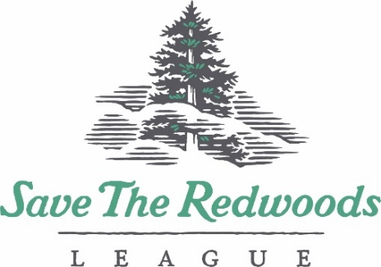

Redwood Connect Grants Application Form 2020-2021

Organization Name:
Project Director:  (Primary contact for all grant related material) |  |  | Title:
Address:
Phone: |  |  | E-mail:
Project Title:
Project Summary: In 400 words or less, briefly summarize and capture the essence of your project, including the objectives and need for grant funding.

Project Participants Information:
Number of participants your project will serve directly.
Description of primary community(ies) served by project, including age and relevant ethnic and socioeconomic information?

Percentage of participants part of the free and reduced price school lunch program? (if applicable)

When will the project take place? |  | From: |  | To:
Location of Field Trip(s)
Redwood Connect Grant Project Theme (check all that apply)
- Redwood ecology
- Climate change
- Health and wellness
- Team/Community building
- Staff development
- Stewardship/Restoration
- Environmental Justice
- Other: ___________________________________

Total Project Budget: $
Briefly describe how project implementation may change if COVID-19 restrictions remain in effect/expand.

Redwood Connect Grant Category
- Redwood Visit (1-day field trip in a Redwood forest) $1,500 Grant Award
- Forest Immersion (3 or more field experiences in a redwood forest or bringing multiple groups on 1 day forest visits) $5,000 Grant Award

Section 2 – Forest Immersion Narrative (required of Forest Immersion applicants ONLY)
Please complete the Application Narrative Form for the Forest Immersion Grant. Attach the narrative to this application form as one PDF. All of the questions must be addressed for your proposal to be considered. The reviewers request that you present your narrative topically, using the numbered headings outlined in the narrative. We do appreciate brevity & clarity!

