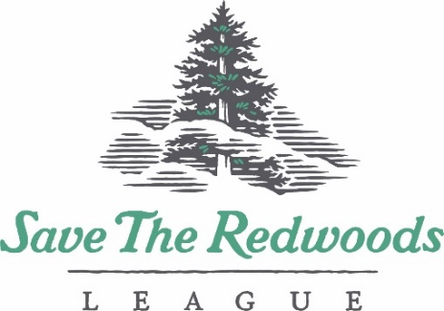

Redwood Connect Grants Application Form 2023-2024

- Organization and Participant Information:
Organization Name/Community Group:
Project Director:
(Primary contact for all grant related material)
Title and Gender Pronouns:
Address:

Phone:
Email:
Number of participants this grant will serve directly.

Description of primary youth served by project, including age and relevant ethnic and socioeconomic information.

- Project Title:

- Project Description:
Please provide a short but detailed description of the project including the objectives and need for grant funding. Please describe how the trip to the redwoods is a key component of the project, what activities you will be doing in the forest and/or how your participants will be interacting with the redwoods. Character limit: 1000

- Project Timeline:
Please describe what will happen at various times throughout the year, planning, recruitment, implementation, post-planning, etc.

- Field Trip Location(s):

- Focus Area (select all that apply)
- Redwood ecology
- Climate change
- Health and wellness
- Team/Community building
- Staff development
- Stewardship/Restoration
- Environmental Justice
- Other: ___________________________________

- Budget
- Total Project Budget:

- Please describe how funding will be used to support your project. A detailed budget table is not necessary.
Character limit: 250

- Reporting Requirement
A short written or visual (through photos and/or video) report is required within 30 days of the completion of the grant period. A template will be provided at least 60 days prior to the end of the grant period and available on our website. Throughout the year, please share any photos, news or related materials with the League.

** If selected to receive a grant your organization will need to provide a 501c3 Determination Letter (first time applicants only), a current W-9 and a Direct Deposit Form (provide by the League).

