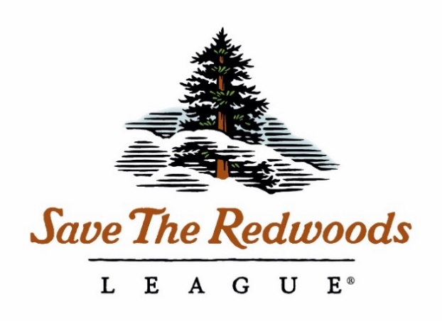
(Enter Your Proposal Project Name Here)
2018 Pre-Proposal

Proposed start date:
Proposed end date:
Funds requested:

Primary investigator (PI):
Position/Title:
Institution:
Mailing Address:
Telephone:
Email address:

Co-investigator (Co-PI):
Position/Title:
Institution:
Mailing Address:
Telephone:
Email address:

Additional Collaborators:
Name | Title and Affiliation

Is this proposal a continuation of a project previously funded by Save the Redwoods League?
☐ No
☐ Yes:
Grant No. | Title

Preproposal must not exceed 2 pages, excluding references and cover page. Send pdf to science@savetheredwoods.org by 9/18/2018. Delete all italicized instructions and re-name the file, replacing PI Last Name and keywords (e.g., “PreProposal_Smith_BurritosSalsa_2018.pdf”).

- Research questions
- Please list core research questions addressed by the proposal in bulleted format.

- Purpose and Need
Please use this introduction section to describe the purpose and need for the research, including what is known and where the data gaps are.

- Relevance to Conservation
Discretely describe the relevance of the research to conservation and forest stewardship. How can the League use this information to be better forest stewards?

- Methods

- Deliverables
Please list all deliverables proposed for the grant award. Examples include a peer-reviewed manuscript (strongly preferred), outreach events such as field tours with forest managers about results, etc. At minimum annual progress reports will be due on November 1st, and a final report is required. Both reports must use the League template. Add a follow-up narrative describing delivered products in more detail as needed.

Deliverable | Planned Completion Date

- References
References will not count towards the 2 page limit.

- CV’s
Please attach PI and Co-PI CV’s to the end of the proposal.

