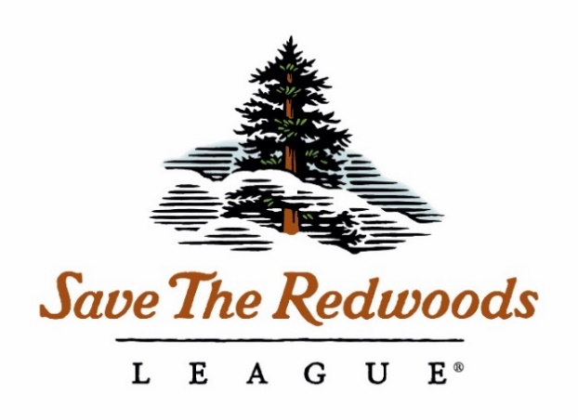
(Enter Your Proposal Project Name Here)
2020 Pre-Proposal

Proposed start date:
Proposed end date:
Funds requested:

Primary investigator (PI):
Position/Title:
Institution:
Mailing Address:
Telephone:
Email address:

Co-investigator (Co-PI):
Position/Title:
Institution:
Mailing Address:
Telephone:
Email address:

Additional Collaborators:
Name | Title and Affiliation

Is this proposal a continuation of a project previously funded by Save the Redwoods League?
☐ No
☐ Yes:
Grant No. | Title

Preproposal must not exceed 2 pages, excluding this cover page and any references. Send pdf to science@savetheredwoods.org by 9/4/2020. Delete all italicized instructions int his document and re-name the file, replacing PI Last Name and keywords (e.g., “PreProposal_Smith_BurritosSalsa_2019.pdf”).

- Research questions
- Please list core research questions addressed by the proposal in bulleted format.

- Purpose and Need
Please use this introduction section to describe the purpose and need for the research, including what is known and where the data gaps are.

- Methods
Please describe the intended research methods to address your research questions.

- Relevance to Conservation
Discretely describe the relevance of the research to conservation and forest stewardship in a short paragraph. How can the League use this information to be better forest stewards?

- Contributions to Diversity
Please briefly state how support for the proposed project may contribute to diversity, equity and inclusion in redwood research. Details on how your lab or work group integrates these values are also appropriate, particularly if the proposed project may have limited opportunities to directly impact diversity, equity and inclusion.

- Deliverables
Please list all deliverables proposed for the grant award. Examples include a peer-reviewed manuscript (strongly preferred), outreach events such as field tours with forest managers about results, etc. At minimum annual progress reports will be due on November 1st, and a final report is required. Both reports must use the League template. Add a follow-up narrative describing delivered products in more detail, if needed.

Deliverable | Planned Completion Date

- References
References will not count towards the 2 page limit.

- CV’s
Please attach PI and Co-PI CV’s to the end of the proposal.

